Digital Blue Ocean Strategy—using digital technology to create a new market space rather than simply competing with existing businesses on the same factors.
The key tool is the Four Actions Framework:
Eliminate → Reduce → Raise → Create

1. Airbnb — Redefining Accommodation

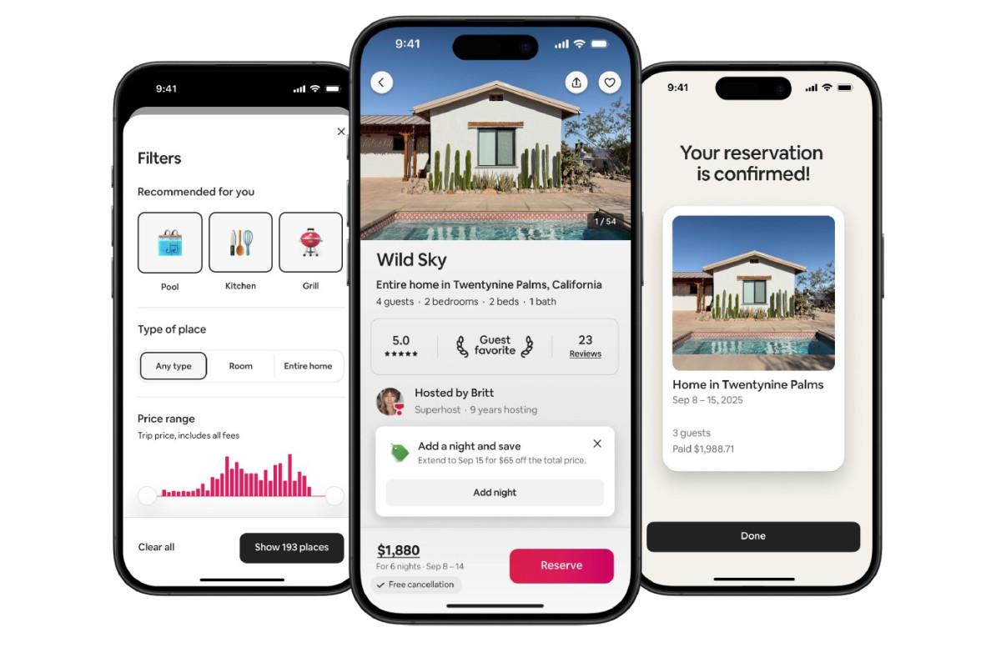

Before Airbnb, accommodation competition was dominated by hotels and resorts.
Traditional model:
Hotel building → Hotel room → Guest
Airbnb created a different model:
Homeowner → Digital platform → Traveller
Four Actions Framework
Action | What Airbnb did
🔴 Eliminate | Need for every accommodation provider to own/build a hotel
🟡 Reduce | Dependence on physical hotel infrastructure and traditional booking processes
🟢 Raise | Variety of accommodation choices, customer reviews and convenience
🔵 Create | A peer-to-peer marketplace where ordinary people can become accommodation hosts

Why is this "Blue Ocean"?
Airbnb did not simply build another hotel chain.
It created a digital marketplace connecting unused accommodation with people looking for places to stay.

Student takeaway
Airbnb used a digital platform to turn underutilised resources—people's homes—into a new source of accommodation.

2. Netflix — Changing How People Consume Entertainment

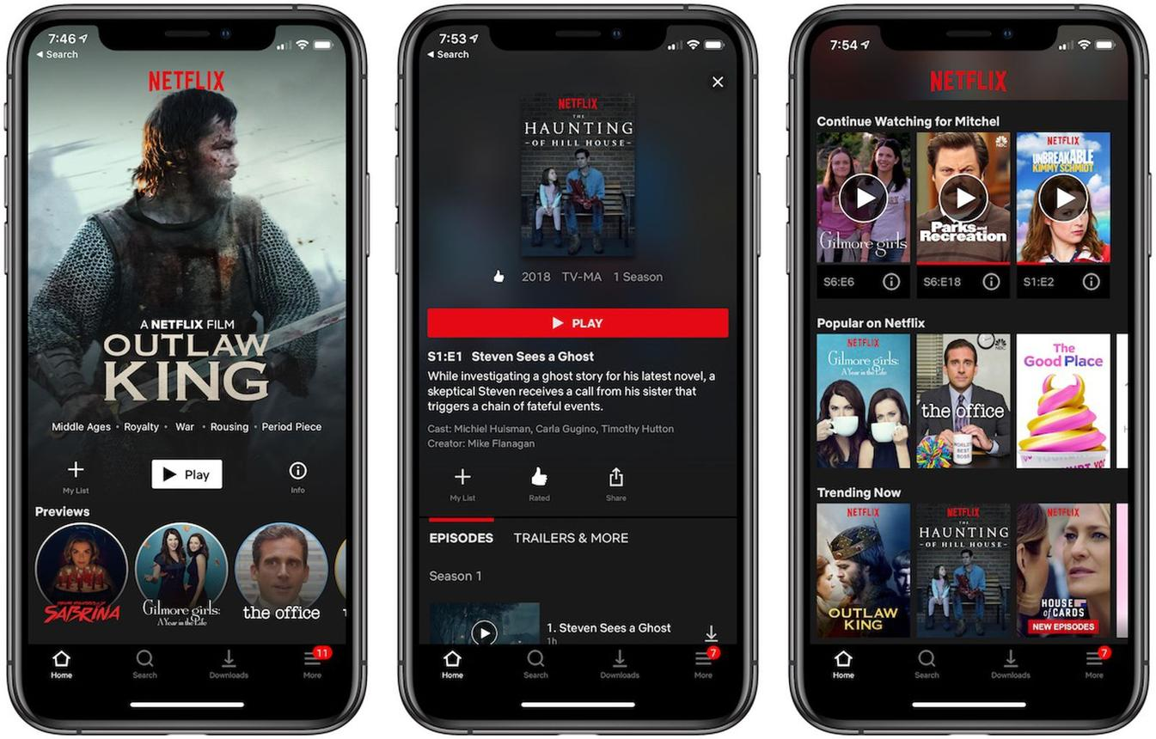
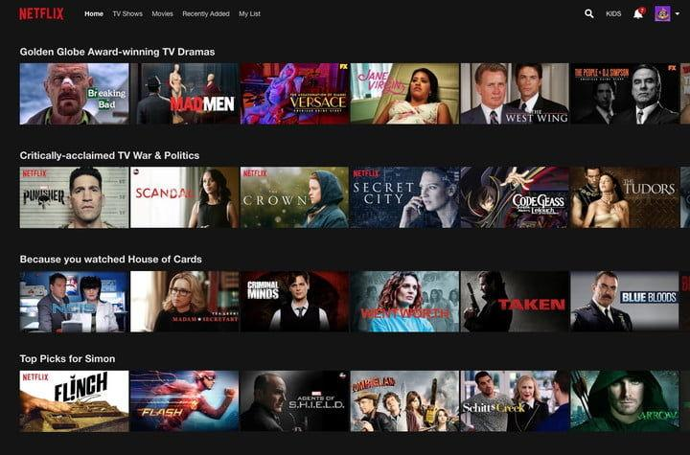
The traditional video-rental model required customers to visit a physical store and rent DVDs.
Netflix progressively moved toward:
Internet → Streaming platform → Customer
Four Actions
Action | Netflix example
🔴 Eliminate | Physical store visits and physical DVD handling for streaming customers
🟡 Reduce | Waiting time and dependence on physical inventory
🟢 Raise | Convenience, content accessibility and personalisation
🔵 Create | On-demand streaming and algorithm-based recommendations

Example
Traditional:
"I need to go to the video store to rent a movie."
Netflix:
"I can watch it immediately from home."
The customer value curve changed from physical access to digital, on-demand access.
3. Spotify — Changing the Way People Access Music
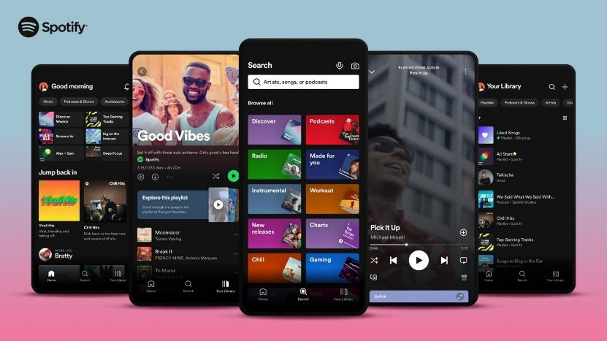
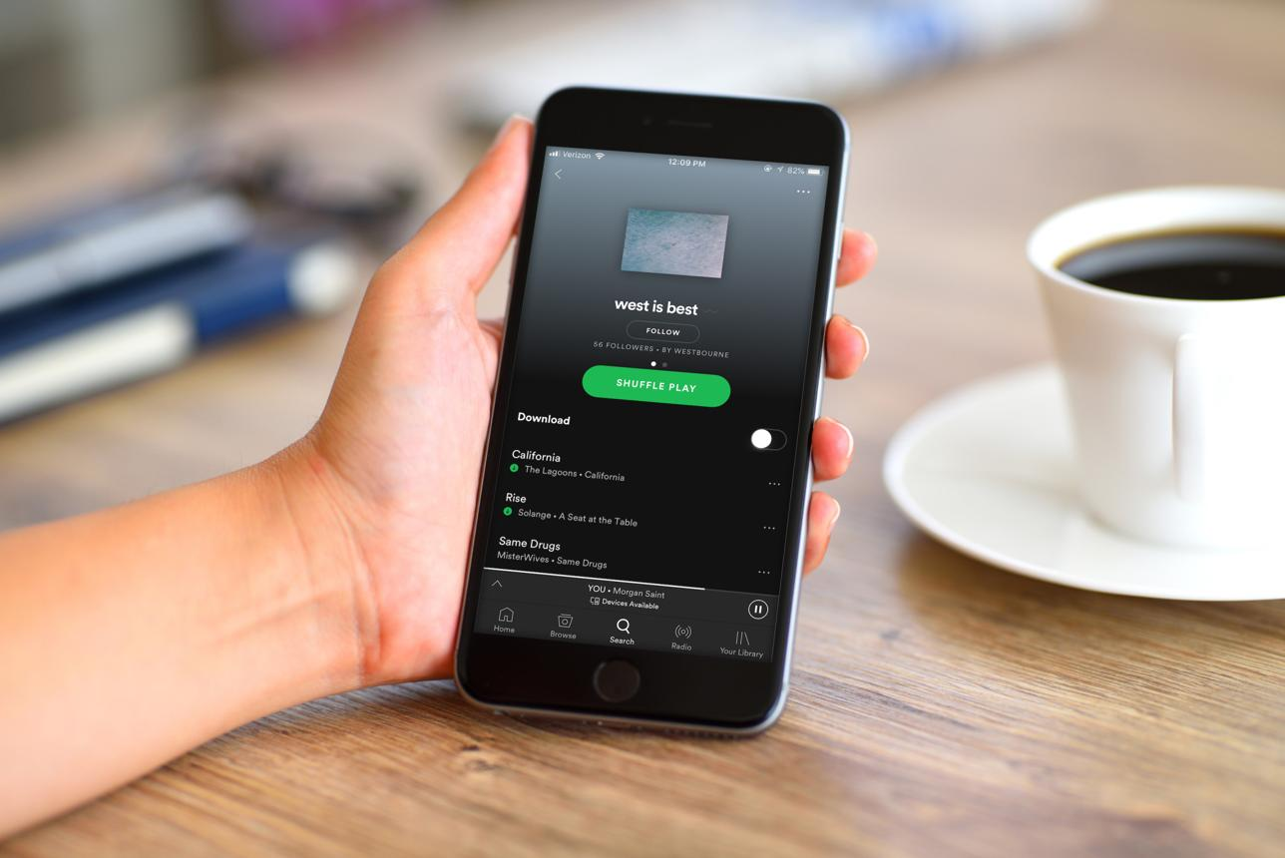
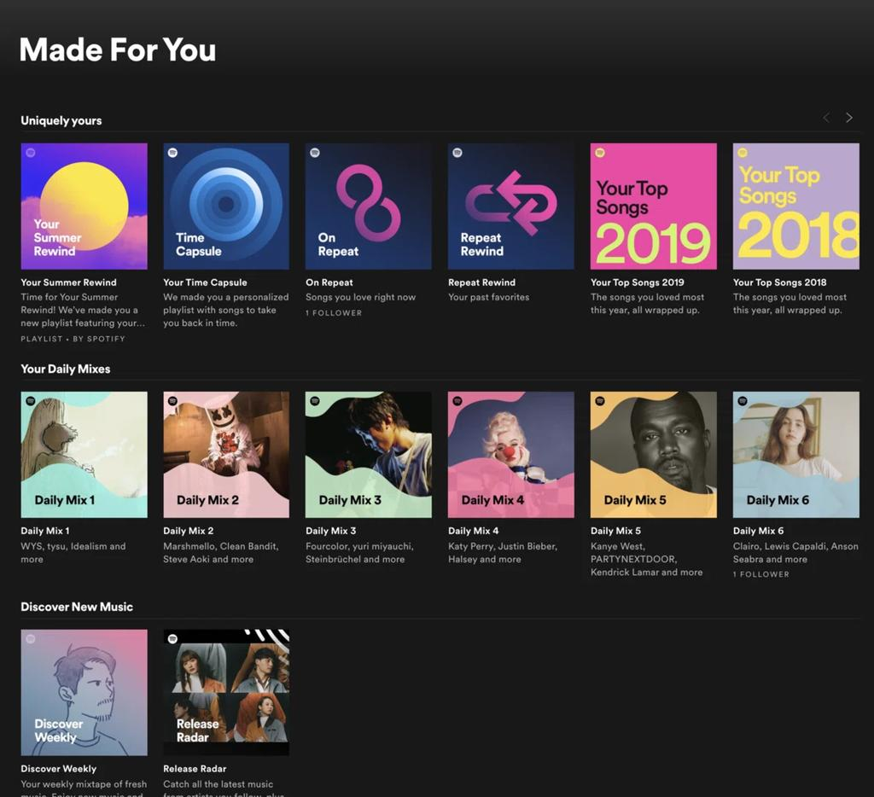

Traditional music consumption involved:
Buy CD → Own music → Play CD
Spotify changed the model to:
Subscribe/use service → Stream music → Personalised experience
Four Actions
Action | Spotify example
🔴 Eliminate | Need to purchase individual physical albums
🟡 Reduce | Cost and effort associated with acquiring individual songs
🟢 Raise | Convenience, music discovery and personalisation
🔵 Create | On-demand streaming, personalised playlists and algorithmic recommendations

New value created
Spotify doesn't just provide songs.
It can provide:
Music + discovery + recommendations + playlists + social sharing
The digital technology creates a much broader customer experience.

4. Grab — Creating an Integrated Digital Service Ecosystem
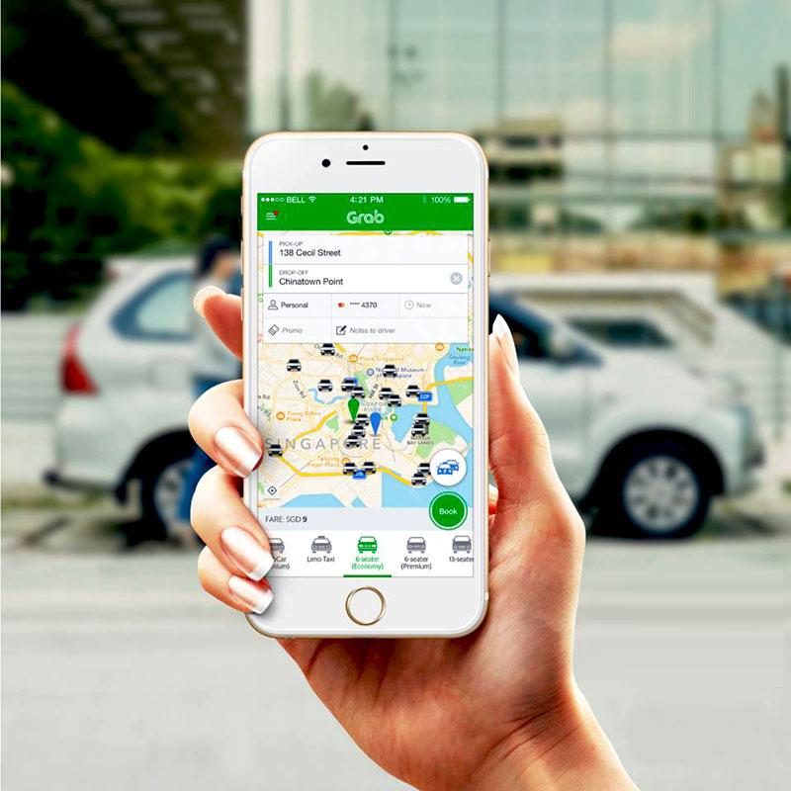
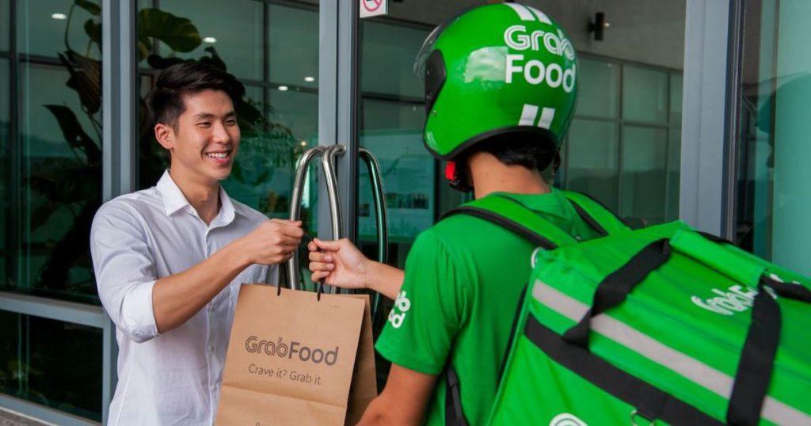
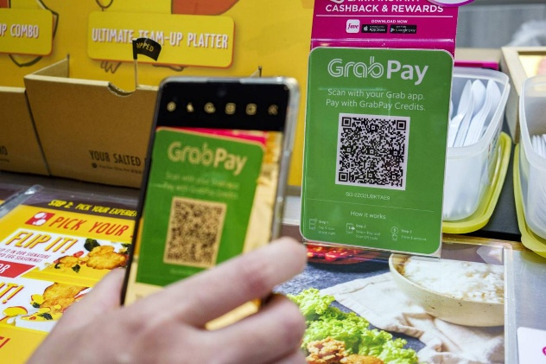
Grab is an excellent example for students because it demonstrates multiple digital services being combined into one ecosystem.

Originally, ride-hailing solved:
"How do I get a ride?"
The broader digital ecosystem can address:
"How do I move, eat, pay and access services?"
Four Actions
Action | Grab example
🔴 Eliminate | Traditional street-hailing and some manual booking processes
🟡 Reduce | Waiting time, uncertainty about fares and cash handling
🟢 Raise | Convenience, tracking, transparency and personalised services
🔵 Create | Integrated digital ecosystem for mobility, food delivery, payments and other services

Example
Traditional taxi:
Stand by roadside → Find taxi → Negotiate/estimate fare → Ride → Pay
Digital:
Open app → Select destination → See estimated fare → Book → Track driver → Digital payment → Rate driver
The entire customer journey is digitally redesigned.

5. Canva — Making Graphic Design Accessible
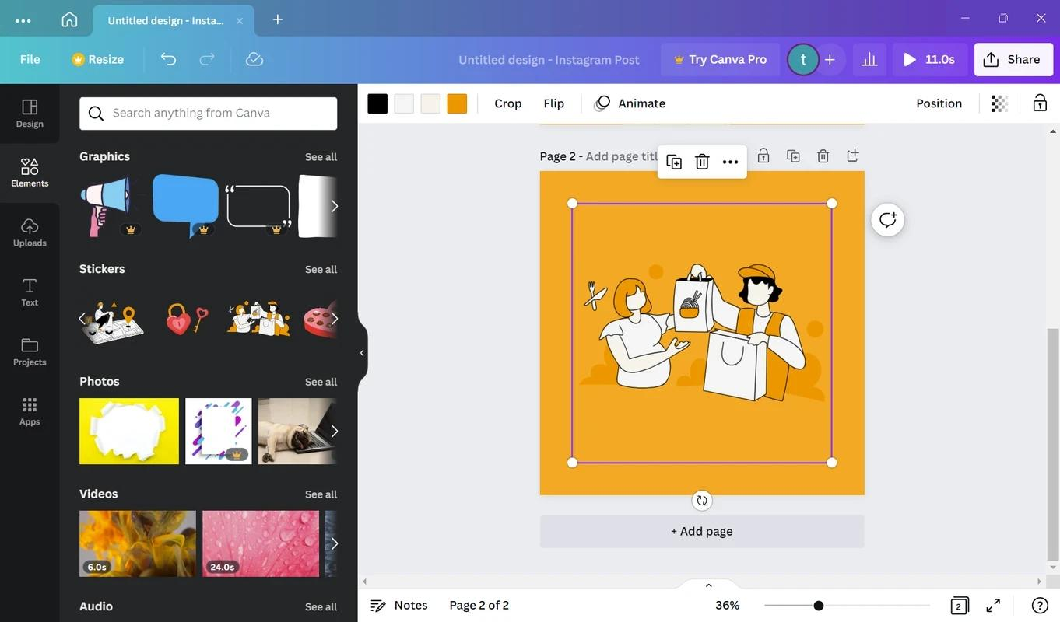

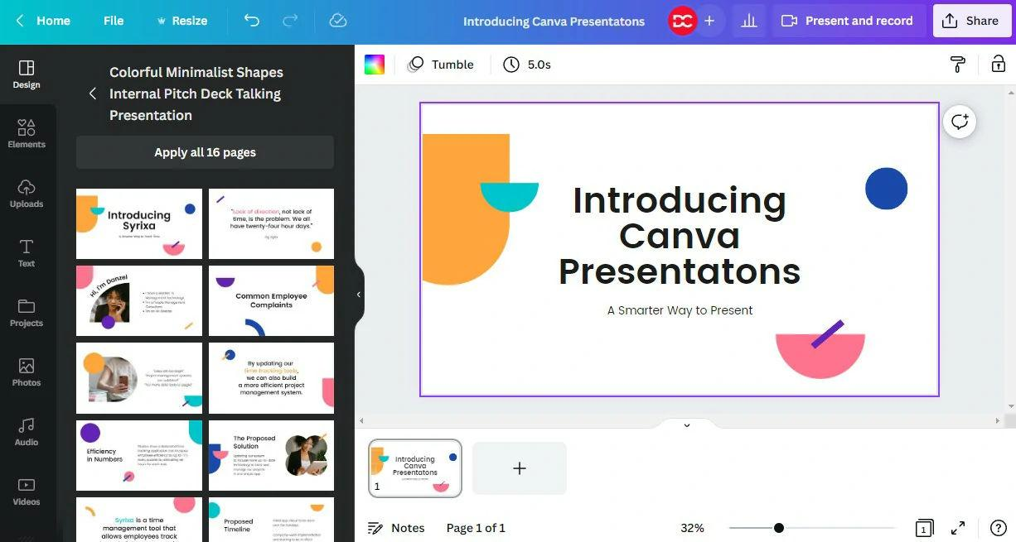

Before easy-to-use online design platforms, professional graphic design could require:
- Specialist software
- Design skills
- Professional designers
- Significant time
Canva changed the value proposition.
Four Actions
Action | Canva example
🔴 Eliminate | Need for advanced design knowledge for many everyday designs
🟡 Reduce | Time and complexity of creating graphics
🟢 Raise | Ease of use, accessibility and template availability
🔵 Create | Self-service online design using templates, drag-and-drop tools and collaboration

Example
A student needs a poster.
Traditional approach:
Learn complex design software → Create design → Export → Print
Canva approach:
Choose template → Edit → Download/share
Blue Ocean idea
Canva expanded graphic design from primarily professional designers to ordinary users, students, teachers and small businesses.

6. Duolingo — Digitalising Language Learning
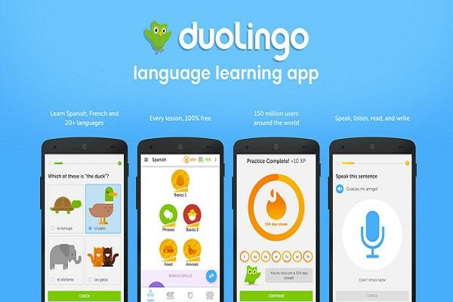
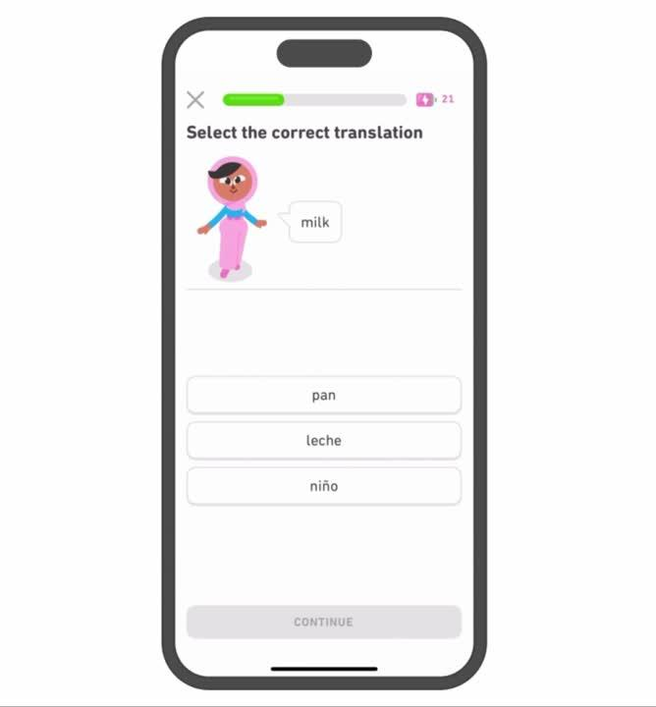
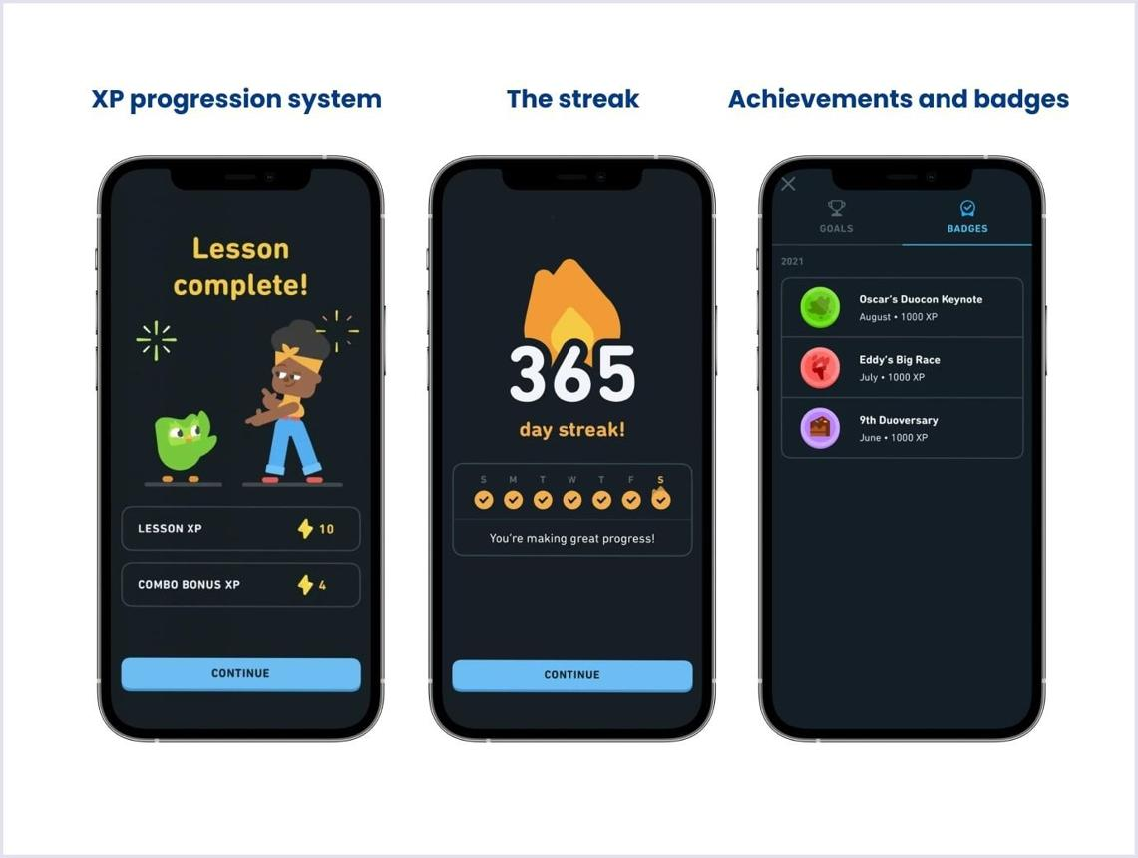
Traditional language learning might involve:
Classroom → Teacher → Textbook → Scheduled lessons
Duolingo provides:
Smartphone → App → Short lessons → Automated feedback
Four Actions
Action | Duolingo example
🔴 Eliminate | Requirement to attend a physical classroom for basic practice
🟡 Reduce | Cost and time commitment
🟢 Raise | Convenience, engagement and accessibility
🔵 Create | Gamified language learning, streaks, points and personalised digital practice

The important innovation isn't simply "put language lessons online."
It is the combination of:
Mobile + AI/data + gamification + freemium + personalised learning

7. Uber — Redesigning Urban Transportation
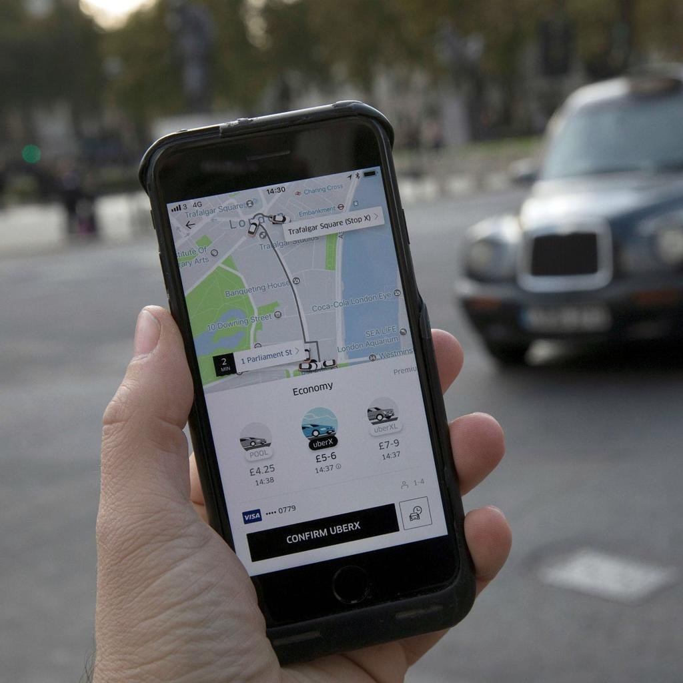
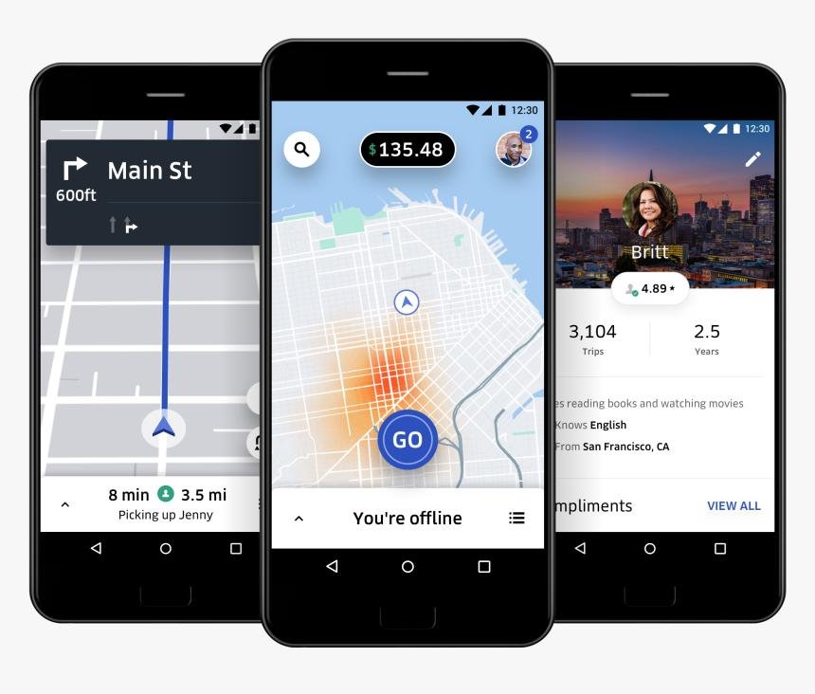
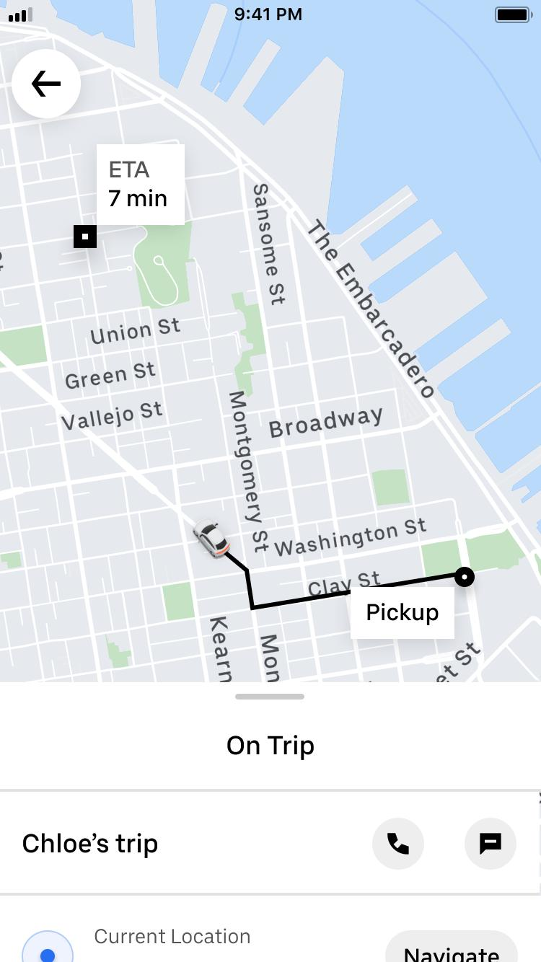
Uber used a digital platform to connect passengers and drivers.
Four Actions
Action | Uber example
🔴 Eliminate | Some traditional taxi-booking friction
🟡 Reduce | Waiting uncertainty and cash transactions
🟢 Raise | Convenience, visibility, tracking and transparency
🔵 Create | App-based driver-passenger matching and real-time trip tracking
The key digital innovation
The smartphone becomes the interface connecting supply and demand.
Driver has available capacity
↓
Digital platform
↓
Passenger needs transportation

8. Amazon — From Online Store to Digital Marketplace
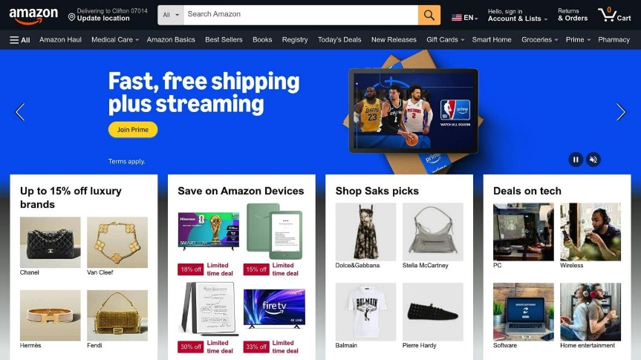
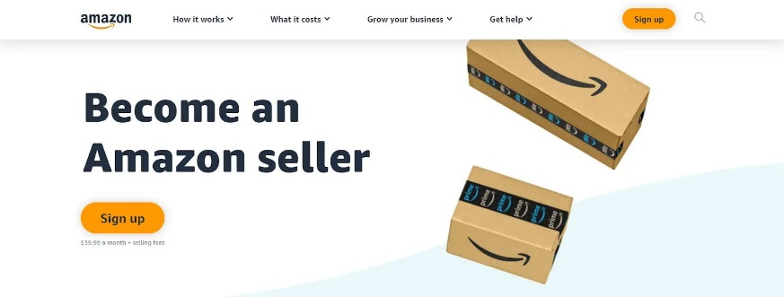
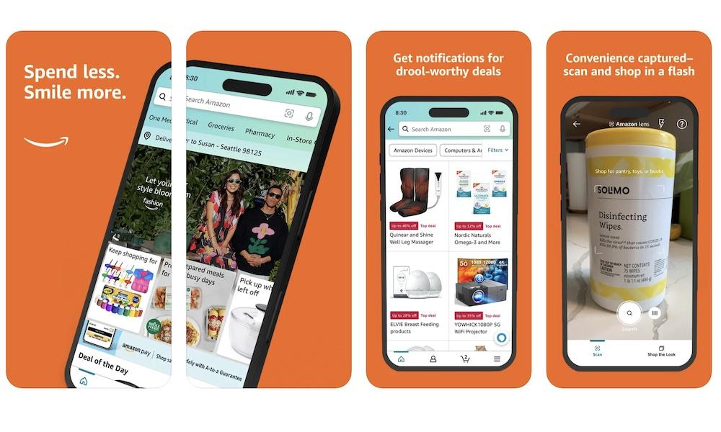
Traditional retail:
Manufacturer → Wholesaler → Physical retailer → Customer
Amazon helped transform this into a digital marketplace.

Four Actions
Action | Amazon example
🔴 Eliminate | Need for customers to physically visit many stores
🟡 Reduce | Search and comparison time
🟢 Raise | Product variety, convenience and price comparison
🔵 Create | Large-scale digital marketplace connecting third-party sellers with customers

The important concept is that Amazon isn't simply an online shop.
Its platform can connect:
Sellers ↔ Amazon platform ↔ Customers ↔ Logistics/payment ecosystem

An Important Point: Blue Ocean ≠ Just Using Technology
This is a common misunderstanding.
Simply putting an existing service online does not automatically create a Blue Ocean.
Example
A restaurant creates a website that displays its menu.
That is:
Digitalisation
But it may not be:
Digital Blue Ocean Strategy
Now imagine the restaurant creates a platform that connects:
Home cooks + customers + delivery riders + local food producers
and allows customers to order personalised meals based on dietary preferences.
That has much greater potential to create a new value proposition and market space.

The Four Actions Framework in Simple Terms
Tell students to ask these four questions:
🔴 ELIMINATE
What can we completely remove?
Examples:
- Physical paperwork
- Waiting
- Physical branches
- Middlemen
- Complex processes
🟡 REDUCE
What can we make less expensive, slower, difficult or inconvenient?
Examples:
- Cost
- Time
- Complexity
- Customer effort
- Transaction friction
🟢 RAISE
What should we provide more of than competitors?
Examples:
- Convenience
- Speed
- Personalisation
- Quality
- Transparency
- Customer experience
🔵 CREATE
What completely new value can digital technology enable?
Examples:
- On-demand services
- Digital marketplaces
- AI recommendations
- Peer-to-peer services
- Subscription models
- Personalised experiences

A Very Practical Classroom Example
Give students this scenario:
Traditional local restaurant wants to create a Digital Blue Ocean strategy.
Ask them to complete:
Four Actions | Student Question
🔴 Eliminate | What traditional restaurant activities can we remove?
🟡 Reduce | What customer frustrations can we reduce?
🟢 Raise | What aspects of customer experience can we improve?
🔵 Create | What completely new digital service can we introduce?
Possible answer
ELIMINATE
- Paper menus
- Manual reservations
- Cash-only transactions
REDUCE
- Waiting time
- Ordering errors
- Customer effort
RAISE
- Personalisation
- Convenience
- Customer engagement
CREATE
- AI-powered menu recommendations
- Digital loyalty programme
- Real-time order tracking
- Subscription meal plans
- Personalised meal packages
Result
Instead of competing with:
Restaurant A vs Restaurant B vs Restaurant C
the business tries to create a different value proposition:
"A personalised, technology-enabled dining experience."

